Write a function to delete a node (except the tail) in a singly linked list, given only access to that node.

Given linked list -- head = [4,5,1,9], which looks like following:

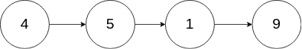

**Example 1:**

**Input:** head = [4,5,1,9], node = 5

**Output:** [4,1,9]

**Explanation:** You are given the second node with value 5, the linked list should become 4 -> 1 -> 9 after calling your function.

**Example 2:**

**Input:** head = [4,5,1,9], node = 1

**Output:** [4,5,9]

**Explanation:** You are given the third node with value 1, the linked list should become 4 -> 5 -> 9 after calling your function.

**Note:**

* The linked list will have at least two elements.
* All of the nodes' values will be unique.
* The given node will not be the tail and it will always be a valid node of the linked list.
* Do not return anything from your function.